
Input | Instrument | Microphones | Insert | Monitor
1 | Kick Out | Shure Beta 52, Audix D6, e602/902 (no others!) |  | X
2 | Snare top | SM 57, Audix i5, e604, e904 |  | X
3 | Hi-Hat | KM184, SM81, AKG C1000, ATM33a, Pro 37, KSM137, 141, |  | X
4 | Tom | Beta 98, Sennheiser e604, e904, EV ND468
5 | Floor Tom | Beta 98, Sennheiser e604, e904, EV ND468
6 | OH L | KM184, AKG C1000, ATM33a, SM81, NT1 |  | X
7 | OH R | KM184, AKG C1000, ATM33a, SM81, NT1 |  | X
8 | Bass Line | XLR |  | X
9 | Guitar L | Sennheiser e609, e906, SM57, EV ND468 |  | X
10 | Guitar R | Sennheiser e609, e906, SM57, EV ND468 |  | X
11 | Sax | Włąsny |  | X
12 | Sax FX | ACTIVE D-Box |  | X
13 | Sax FX | ACTIVE D-Box |  | X
14 | Lead Vocal Left | Own |  | X
15 | Lead Vocal Right | Audix OM5, Beta 58 we do not agree for SM58 |  | X
16 | Vocal Sax (Right) | Shure SM58 |  | X
 | Reverb L
 | Reverb R
 | Tap Delay L
 | Tap Delay R
 | PC/CD L | D-Box
 | PC/CD R | D-Box
 | Talkback Mic. | ON/OFF switch |  | X

TECHNICAL RIDER 2016

PA SYSTEM

Clubs: min. 5kW RMS side. Open Airs: min. 15kW RMS side, 100dBa on FOH; system ought to be ready one hour before band’s sound check.
Systems we don’t accept: „homemades” and YAMAHA, LEM, PEAVEY, MACKIE, ELECTROVOICE (ELIMINATOR, FORCE, etc.)
We prefere digital mixers: Yamaha, Soundcraft, Digidesign, Digico, A&H, Midas. All mixers having 16 faders in layer and 8 X AUX.
We do not accept mixers: VERMONA, ROLAND, PRESONUS, BEHRINGER (except x32) and similar.
We need frontfill. Even in clubs.

PERIPHERY for analog mixers

Compressors, gates and equalizers with full regulation of all parameters.
we accept: BSS, DBX, DRAWMER and similar.
we don’t accept: BEHRINGER, ADS, PHONIC etc.
Reverb – Lexicon PCM81, Yamaha REV500, Yamaha SPX990 or TC ELECTRONIC M-ONE etc.
Delay- every device of reputable labels endued with tap!

EFFECT’S PROCESSORS

- Reverb – Lexicon PCM81, Yamaha REV500, Yamaha SPX990 or TC ELECTRONIC M-ONE etc.
- Tap Delay – TC ELECTRONIC M-ONE , TC ELECTRONIC D-TWO itp.

MONITOR SYSTEM
We need separate monitor system. Mixer ought to have 6 monitor tracks. We do not use compressors in monitor system. We need 6 wedges. We do not need PFL wedge.

Track 1 | 1 x wedge | Gieno – bass
Track 2 | 2 x wedge | Yellow – guitar, vocal
Track 3 | 2 x wedge | Wróbel – guitar, vocal
Track 4 | 1 x wedge | Sosna – sax, vocal
Track 5 | 1 x wedge | Mikołaj – track to mixer

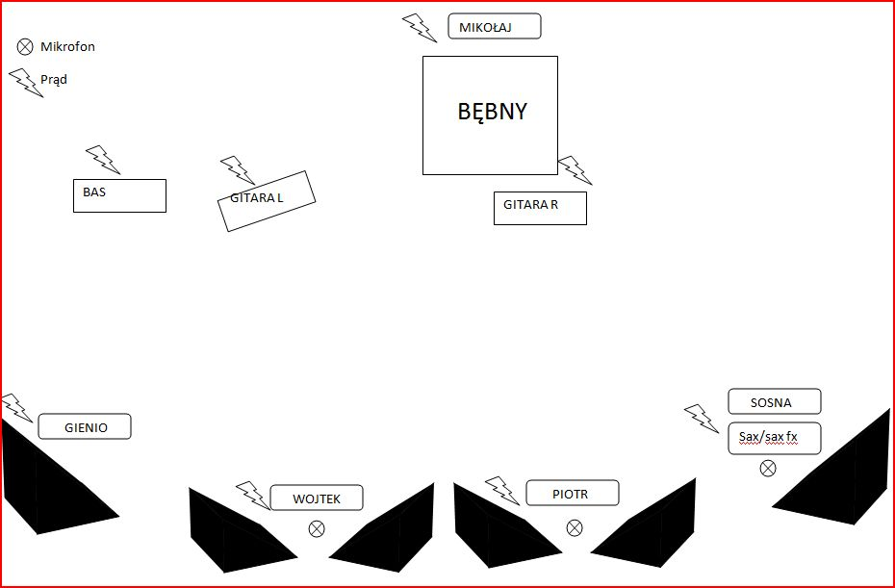

management: sound engeener:
PEEF MUSIC Daniel ZIÓLEK Bigaj
Filip Herma, filip@peefmusic.pl ziolek1976@windowslive.com
(+48) 600 201 892 (+48) 501 194 751

